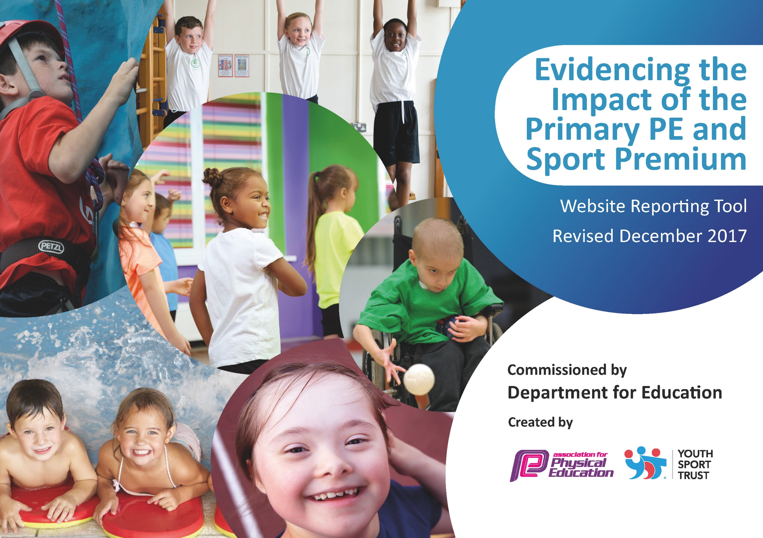

Schools must use the funding to make additional and sustainable improvements to the quality of PE and sport they offer. This means that you should use the Primary PE and Sport Premium to:

- develop or add to the PE and sport activities that your school already offers
- build capacity and capability within the school to ensure that improvements made now will benefit pupils joining the school in future years

Please visit gov.uk for the revised DfE guidance including the 5 key indicators across which schools should demonstrate an improvement. This document will help you to review your provision and to report your spend. DfE encourages schools to use this template as an effective way of meeting the reporting requirements of the Primary PE and Sport Premium.

We recommend you start by reflecting on the impact of current provision and reviewing the previous spend.
Under the Ofsted Schools Inspection Framework, inspectors will assess how effectively leaders use
the Primary PE and Sport Premium and measure its impact on outcomes for pupils, and how effectively governors hold them to account
for this.

Schools are required to publish details of how they spend this funding as well as on the impact it has on pupils’ PE
and sport participation and attainment.
We recommend regularly updating the table and
publishing it on your website as evidence
of your ongoing review into how you are using the money
to secure maximum, sustainable impact. To see an example of how to complete the table please click HERE.

Support for review and reflection - considering the 5 key indicators from DfE, what development needs are a priority for your setting and your students now and why? Use the space below to reflect on previous spend, identify current need and priorities for the future.

Key achievements to date: | Areas for further improvement and baseline evidence of need:
Over the last few years we have become very involved in competition with other schools.  We have been working to develop staff confidence in teaching PE.  We have been improving the opportunities for extra-curricular sport at our school.  We have chosen a sports crew. | We would like to make these opportunities available to all children and not just school teams.  Staff felt that more CPD would be valuable so we are investing in this in order to improve the quality of our PE teaching in the long term.  We need to increase this provision and use initiatives to target the least active children.  We need to make the children themselves more pro -active in encouraging activity at playtimes.

Meeting national curriculum requirements for swimming and water safety | Please complete all of the below*:
What percentage of your current Year 6 cohort swim competently, confidently and proficiently over a distance of at least 25 metres? | Year 6 were unable to go swimming due to covid. Hopefully we will go again after May 2021.
What percentage of your current Year 6 cohort use a range of strokes effectively [for example, front crawl, backstroke and breaststroke]? | As above.
What percentage of your current Year 6 cohort perform safe self-rescue in different water-based situations? | As above.
Schools can choose to use the Primary PE and Sport Premium to provide additional provision for swimming but this must be for activity over and above the national curriculum requirements. Have you used it in this way? | No
*Schools may wish to provide this information in April, just before the publication deadline.

Action Plan and Budget Tracking
Capture your intended annual spend against the 5 key indicators. Clarify the success criteria and evidence of impact that you intend to measure to evaluate for students today and for the future.

Academic Year: 2020/21 | Total fund allocated: £16,230 | Date Updated:22.2.2021
Key indicator 1: The engagement of all pupils in regular physical activity – Chief Medical Officer guidelines recommend that primary school children undertake at least 30 minutes of physical activity a day in school |  |  |  | Percentage of total allocation:
 |  |  |  | 22% £3640
School focus with clarity on intended impact on pupils: | Actions to achieve: | Funding allocated: | Evidence and impact: | Sustainability and suggested next steps:
The school has been working to make all children more active at playtimes, lunchtimes and after school as well as sometimes during lessons. This has been a challenge during Lockdown. We have set daily and weekly activities for the children at home and sent prerecorded exercise challenges for the children from our PE coordinator. | Children to organize a variety of activities each lunchtime and break time if the interest is there.  The 4 Sports crew to organize traditional active games such as swim fishy swim and stuck in the mud. Stickers to be awarded for participation to encourage more children to join in.  Provide after school clubs with opportunities to be active for any child who wishes to take advantage of it. Pupil Premium pupils can access these if needed.  If Bubbles allow, we will restart offering a variety of activities each playtime. These will include :  Basketball, tennis, football, dodgeball and rugby.  Each child will complete the Daily Mile. | None  Tennis club costs= £1300  £840  £1500 | .  The Change for Life team of 4 will independently advertise their lunchtime club which they are running once a week. They will be targeting the least active pupils  Our PE trained TA runs clubs for outdoor sports on two days a week. There is a good take up from the children for these clubs and she frequently has over 15 attending her tennis club.  For the Autumn Term a coach from Progressive Sport provided an additional free after school club exploring a range of sports such as archery and fencing. He worked alongside 2 teachers to provide CPD.  Lunchtime sports activities have been provided by midday supervisors, TA’s, sports coaches and have been well attended by children of all ages such as a free football club. This was extremely well attended.  This has now been hampered by covid and the necessity for Bubbles but we hope to start again in the Summer Term.  Our PE trained TA runs a playtime club for tennis and football on two mornings a week. Before school she runs a tennis club for all ages . | We will have these 4 children in school until summer 2021, and during their last term they will train a team from the year below to take over.  We hope to be able to continue this provision even if the PE premium drops again as we feel before and after school activity is a priority.  We hope to liaise with QEGS to see if they have any sixth form students studying PE who would be interested in continuing this provision for 2021-22.  Tennis club will continue and we will continue the playtime provision if funds allow. Children are directed towards Ashbourne Tennis Club to further their interest in the sport.  Some of our older pupils joined the local triathlon club and took part in a local event.  Children are directed towards AVEAC or Derby athletic club.
Key indicator 2: The profile of PE and sport being raised across the school as a tool for whole school improvement |  |  |  | Percentage of total allocation:
 |  |  |  | 0%(declared elsewhere)
School focus with clarity on intended impact on pupils: | Actions to achieve: | Funding allocated: | Evidence and impact: | Sustainability and suggested next steps:
At Kniveton Primary we have a culture of extremely high expectations for all our pupils and this is evident throughout the school. We acknowledge that P.E. and Sport has an important part to play in developing the whole child and contributing to their success. Through sport the important qualities of resilience, communication, teamwork and friendship are developed. These skills can then be transferred back into the classroom.  Maintain a “Kniveton in Action “ display which shows evidence of the children taking part in sport in and out of school .  Provide more opportunities for children to be active outside lesson time. | We nurture and encourage sport from our EYFS. Every child has a minimum of 2 hours of curriculum P.E. a week.  This board is in the hall and changes on a regular basis.  Far more opportunities are now being provided for lunchtime, playtime and after school clubs to enable much more participation amongst a high percentage of pupils. | £0  (CPD expenses declared in section 3)  £0  Budget declared in section 1. | Initiatives such as the daily mile/5 minute challenge, and our change 4 life team/ club have resulted in a much higher profile for PE across the school.  We have a sports crew who support activity at playtimes.  Curriculum PE includes a wide variety of opportunities and new sports as well as dance with input from outside experts as well.  Parents can email photos of their children participating in activity out of school and photos of school sport will also be displayed. The board will also be used as a signpost to sports clubs and opportunities in the area.  Lunchtime sports clubs have been provided by midday supervisors, TAs, sports coaches and have been well attended by children of all ages . | We will continue to provide 2 hours of quality PE for all our pupils every week.  The board will be maintained and changed and updated regularly to maintain interest.  (See section 1)

Key indicator 3: Increased confidence, knowledge and skills of all staff in teaching PE and sport |  |  |  | Percentage of total allocation:
 |  |  |  | 49% £8020
School focus with clarity on intended  impact on pupils: | Actions to achieve: | Funding  allocated: | Evidence and impact: | Sustainability and suggested  next steps:
Staff need to have training to increase confidence in teaching PE.  Staff to work alongside Megan Hambly from QEGS, to deliver a series of street dance lessons. Year 5/6 will perform a dance to parents at the end of the term’s work.( covid restrictions permitting) and KS1 and EYFS will do the same.  On teacher to attend EVOLVE course to ensure up to date knowledge of regulations involving trips outside school. | There are no courses at present due to covid restrictions.  Our new PE lead has attended online courses and fed back to all staff re the new changes in PE.  If courses become available then we need to send our P.E. lead on one to cascade to staff.  To purchase a new PE resource  All staff who teach PE to have the opportunity to work alongside a coach from Progressive sports or our own sports coach to develop expertise in sports not usually covered in our PE curriculum.  Opportunities will be given for staff to work alongside each other to observe each other and improve personal practice. This will be an extensive provision throughout the year.  Increased teacher knowledge of how to deliver and teach street dance.  Up to date knowledge of all staff. | £550 plus £400  Supply costs.  £100  (allocation listed in wider opportunities section)  £5850  £600  £350 -course +  £150 supply costs. | The PE coordinator has led staff meetings to pass on guidance to other staff about dance, gymnastics, Health and safety, teaching high quality PE , Teaching early fundamental movement skills, OAA and Athletics.  The PE co-ordinator will use the guidance as she reviews the school PE curriculum over the course of this year in order to work more on developing the core skills.  (See Key indicator 4 section)  2 afternoons a week of PE trained TA working alongside other staff for mutual CPD.  Spring Term work with Megan. One session per week per class.  All trips will have the appropriate documentation completed prior to the trip. | The expertise gained and passed on to other staff should impact on the standard of PE teaching in our school for some years to come.  The school PE curriculum will better reflect the requirements of the new National Curriculum.  (See section 4)  All members of staff will be more confident in their own ability to teach PE.  Teachers will feel more confident teaching street dance  Any future courses attended by this teacher and shared with all staff.
Key indicator 4: Broader experience of a range of sports and activities offered to all pupils |  |  |  | Percentage of total allocation:
 |  |  |  | 13% £2130
School focus with clarity on intended  impact on pupils: | Actions to achieve: | Funding  allocated: | Evidence and impact: | Sustainability and suggested  next steps:
Additional achievements:  The school has committed to providing the opportunity for all 5/6 children to attend a 2 night residential where the opportunity will be given to try out OAA activities which cannot normally be provided in school. Staff will accompany them on these visits and will then direct the children towards opportunities to continue these activities if they are interested. Staff may also be able to use some of these activities in future OAA days.  This visit will take place if covid allows in June 2021. | Y6 (12 children) attend the Whitehall centre at Buxton with Y6 from other local schools. where they will take part in Mountain biking, canoeing, stream scrambling and high ropes courses, as well as wide games in the grounds of the centre at night, and a night hike.  In order to expose the children to a wider range of sports, we will employ a coach from “Progressive Sports” to work alongside staff to teach the core PE skills through a range of sports not previously offered to the children. such as , lacrosse, volleyball, archery, fencing, glow in the dark dodgeball, benchball, and several variations on cricket.  Year 3/ 4 to attend a 6 week block of gymnastics coaching at QEGs  Year 5/6 to attend a 6 week course of trampolining at QEGs  Each class to have session on Zumba, Boxercise and cricket provided by QEGs. | £400 (Cost of staffing the visit)  Budget mentioned in Section 1.  £590  £590  £550 | They will take part in mountain biking,  canoeing, stream scrambling and high ropes courses, as well as wide games in the grounds of the centre at night, and a night hike.  . They will also develop the skills of teamwork and independence. | We will continue to provide this opportunity to our Y6 children. More follow up could be given next year in terms of signposting opportunities to try the activities again such as day courses in the holidays at Whitehall.  We will signpost the children and their parents towards opportunities to take part in some of the activities tried. This will be done through our “Kniveton in Action” board or the school website.  Some of the activities such as bushcraft will be continued during our OAA days at Carsington water later in the year.  The fact that staff are working alongside the coach means that they are learning the rules and principles of the various sports and could provide these opportunities in future.  Children can be signposted towards out of school opportunities to be more active in these sports.  If budget allows we will continue this provision after Easter so staff from all classes have had the opportunity to work with the coach.
Key indicator 5: Increased participation in competitive sport |  |  |  | Percentage of total allocation:
 |  |  |  | 18%£3233
School focus with clarity on intended  impact on pupils: | Actions to achieve: | Funding  allocated: | Evidence and impact: | Sustainability and suggested  next steps:
Opportunities should be given to children in all year groups to participate in competitive sport, as often as possible this opportunity should be given to whole classes of pupils, not just the most gifted. | Membership of the Queen Elizabeth Grammar School SSP which organises cluster events and competitions.  Staffing costs to accompany to tournaments  Cost of transport for attending tournaments.  Membership of the rural Derbyshire SSP allows us to take advantage of opportunities such as bikeability and Change4life initiatives and also to enter open competitions organised at Anthony Gell.  A school sports day will be organised and a PE day will be planned for the summer term.  Class 2 and 3 will set fitness challenges through the year to improve each child’s personal fitness and performance. | £1583  £300  £400  £950  For membership which includes Bikeability gtraining.  £0  £0 | All classes will attend competitive events. Y5/6 have collectively so far entered sportshall athletics and basketball and in the summer will enter Quadkids and rounders. Y3/4 are collectively entering rounders and orienteering. R/Y1/Y2 have collectively entered gymnastics and indoor rounders.  Further opportunities have also been provided by QEGS for teams to enter after school competitions and these sometimes have a competition progression. Our basketball team won the cluster event and are progressing to the district event.  Our Year 6 pupils are given a 2 day bikeability training course in the summer term to encourage them to ride their bikes safely and with road sense.  We enter the open basketball and quadkids events and our strongest athletes go through to compete at district level in the cross country. The progression pathway is also available for other sports should we be successful.  Guidance is given by the Rural Derbyshire SSP on applying for the school games mark.  We hold a traditional sports day with novelty races to provide fun competition.  This year we will also organise, and will involve Y5/6 in the organisation a day to include many sports and the chance for personal improvement and competing against your previous scores, as well as for mini games and tournaments.  During some playtimes a running walking challenge will be set of how many laps of the playground can be completed in 5 minutes. The objective is to improve their own performance each time. | Membership of the QEGS SSP is at the heart of our competitive sport and allows us to compete with a variety of smaller schools, we plan to continue this indefinitely and try to enter even more competitions with multiple teams.  The Rural Derbyshire SSP is at the heart of PE in our area and it is vital that we continue to be members in order to take advantage of the opportunities on offer.  Next year we may look at taking advantage of some of the other initiatives offered such as balance bike training for our younger children in order to improve core stability skills.  Involving the children in arranging the event will help them to realise the key aims of maximum participation and enjoyment.  Having extra opportunity for intra school competition is very important moving forward.  More regular running will aid the children’s fitness levels, improve their cardio vascular strength and make them more successful in athletics and cross country events.

